**PROJECT 2 REPORT**

**Venkata Nagendar Shantiswaroop Adibhatla-1001862413**

**Pooja Dumpala-1001917018**

1**.** Initial upload of data into the database using UI (JavaScript) and python flask is mentioned below:

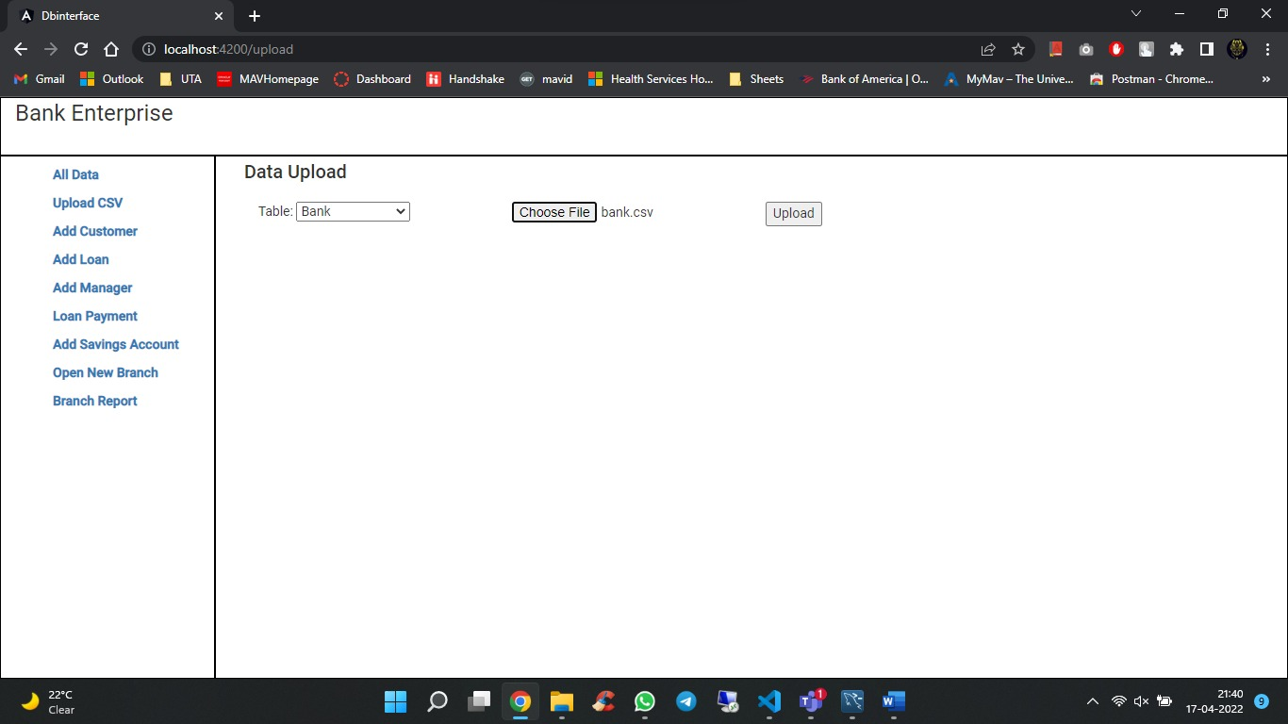

2. Data Present in the table is mentioned in the screenshot below:

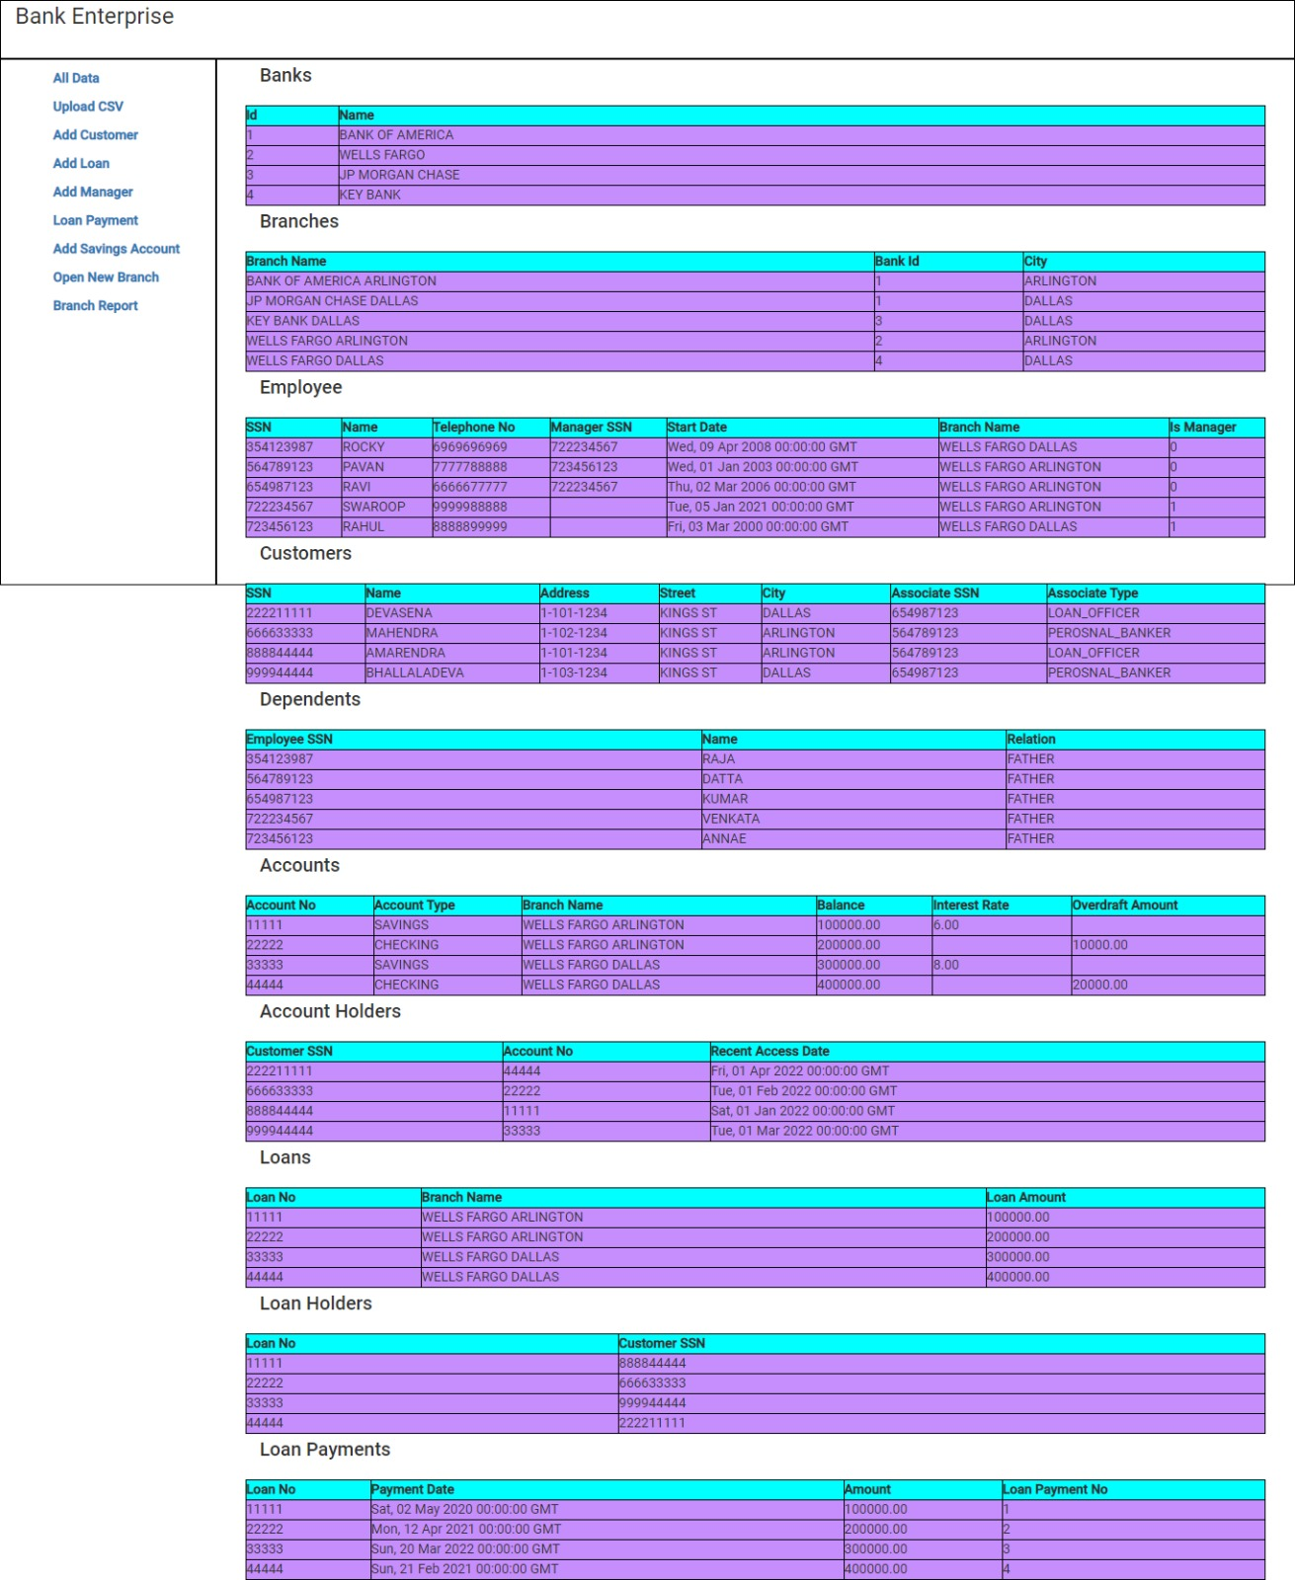

4. We have used the python flask framework to write business logic and update database transactions.

4.1. Add a new customer who is a borrower as well as a depositor.

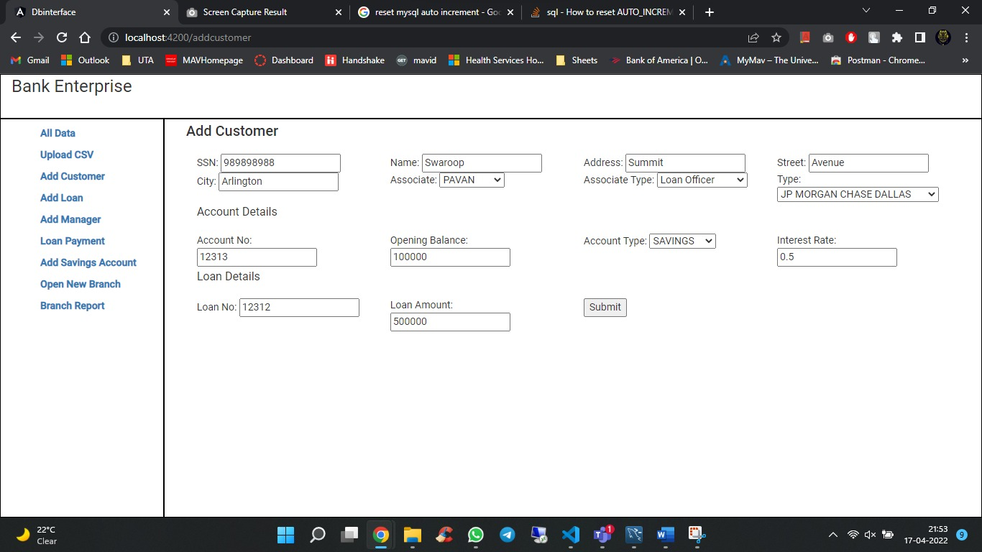

4.2 Are there new loans for the same customer with all loan details?

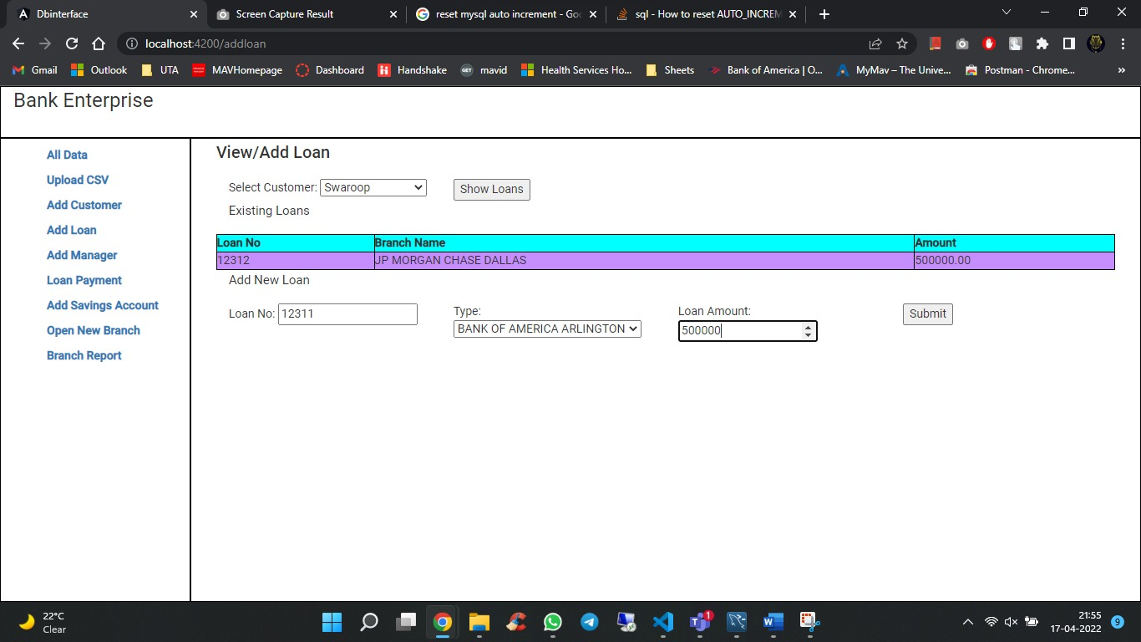

4.3 Add a new employee who’s a manager

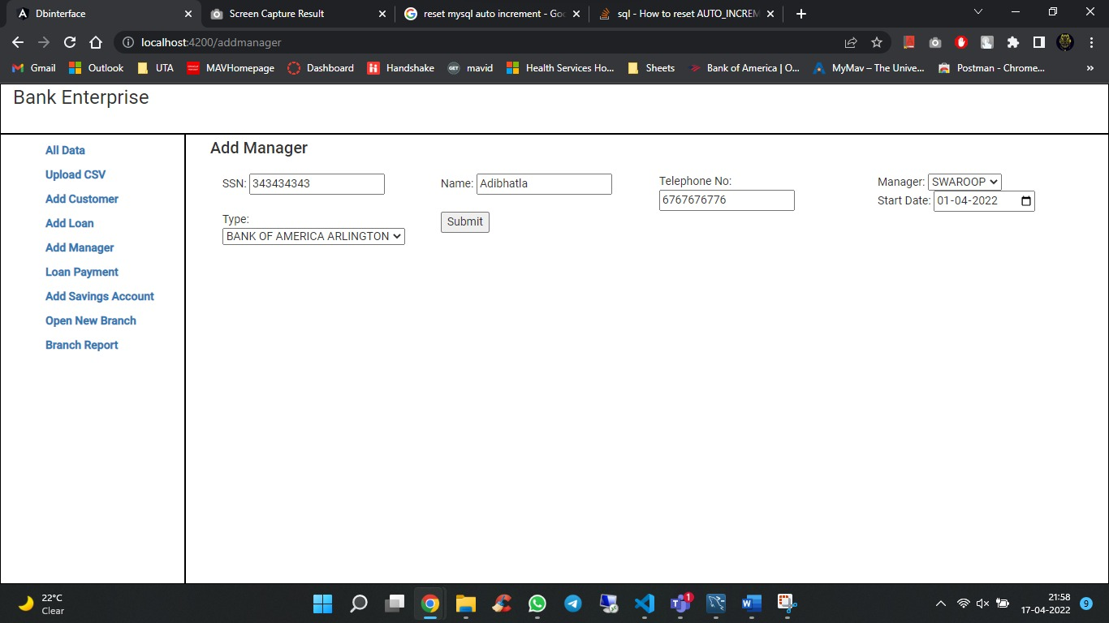

4.4 Executor loan payment transaction.

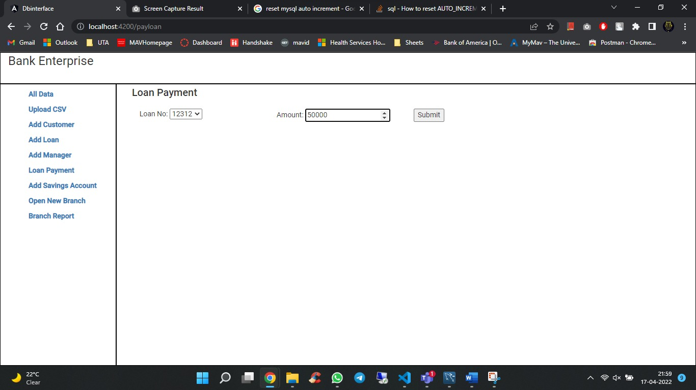

4.5 Add a new savings account for customer

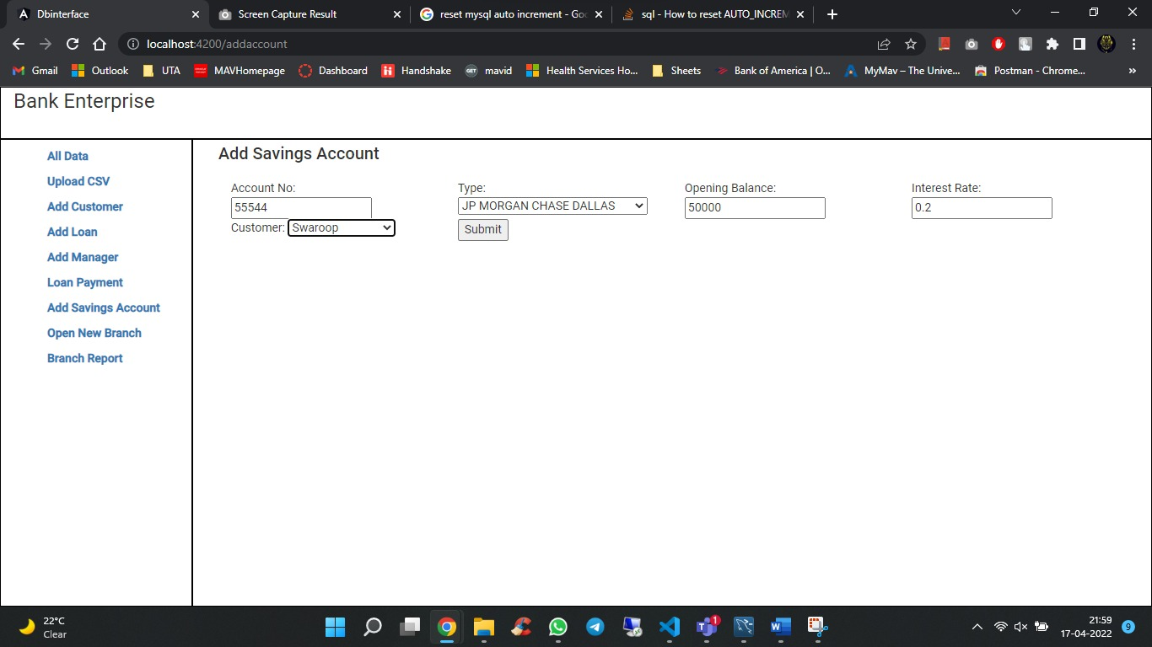

4.6 Open a new branch for a bank

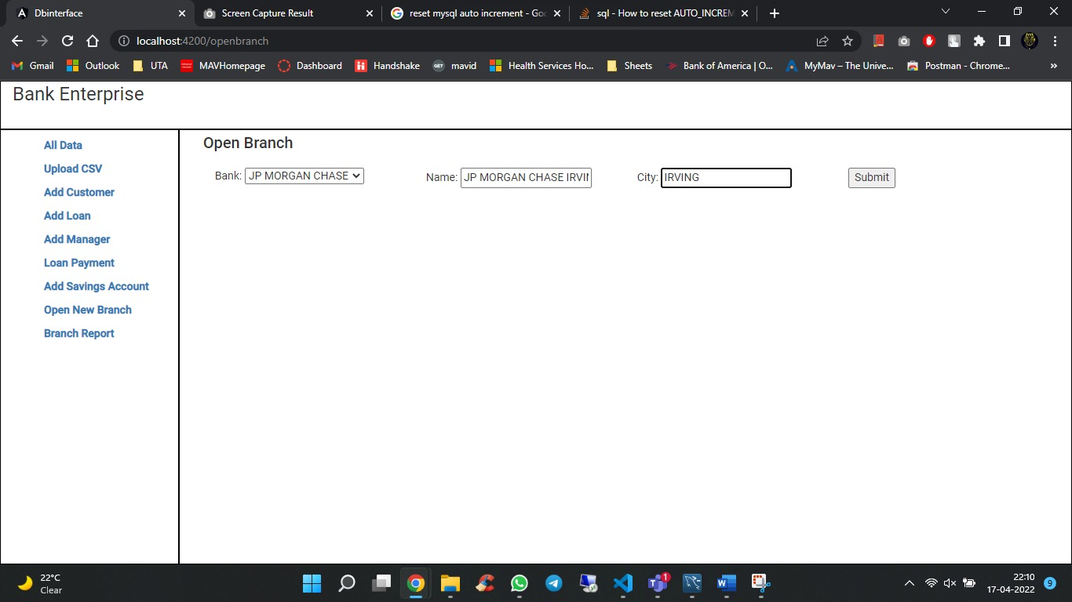

5. Generate a report for a branch containing loans, total outstanding balance against its loans 